SECURITY TESTING REPORT
Unauthorized Admin Access
Broken Access Control – Privilege Escalation Attempt

Target Application | ESCMS – Secure Complaint Management System
Test URL | http://localhost:5173/admin/users
Vulnerability Type | Unauthorized Admin Access – Vertical Privilege Escalation
OWASP Category | A01:2021 – Broken Access Control
Severity | CRITICAL
Test Date | Tue May 05 2026
Tester Role | Student (low-privilege authenticated user)
Test Result | PASSED – Admin routes protected

1. Executive Summary
This report documents the security test conducted against the ESCMS (Secure Complaint Management System) to evaluate whether a low-privilege student account can gain unauthorized access to administrative routes by directly typing admin URLs into the browser.
This technique — commonly known as Forced Browsing or Direct URL Access — is used to test whether the application relies solely on hiding admin links in the UI (security through obscurity) or enforces proper server-side authorization checks for privileged endpoints.
The test specifically targeted: http://localhost:5173/admin/users while authenticated as a standard student user named 'maisam'.
Result: The application correctly restricts access to the admin panel. A student account attempting to navigate to admin routes is denied, confirming that role-based access control (RBAC) is enforced on the server side.

2. Vulnerability Description – Unauthorized Admin Access

2.1 What is Forced Browsing / Unauthorized Admin Access?
Forced Browsing (also called Direct URL Access) is a testing technique that evaluates whether an application properly protects sensitive or privileged URLs. If an application only hides admin links from low-privilege users in the user interface but does not enforce authorization on the server side, any user who knows or guesses the admin URL can access it directly.
Vertical Privilege Escalation occurs when a user with lower privileges (e.g., student) gains access to functionality reserved for higher-privileged roles (e.g., administrator), allowing them to view all users, manage complaints, or alter system settings.

2.2 OWASP Classification
This vulnerability class falls under OWASP Top 10 A01:2021 – Broken Access Control. It is the most critical web application security risk identified by OWASP.

2.3 Potential Impact (if vulnerable)
- Full exposure of all student identities and complaint data
- Ability to modify, delete, or reassign any complaint in the system
- Takeover of administrative functions without credentials
- Severe data privacy violations and regulatory non-compliance
- Complete compromise of system integrity and confidentiality

3. Test Methodology
The following procedure was used to test for Unauthorized Admin Access:
- Log in to the application using a standard student account (username: maisam, role: STUDENT).
- Confirm the logged-in user is a student with no admin privileges via the Dashboard.
- Manually type the admin URL directly into the browser's address bar without using any application links.
- URL tested: http://localhost:5173/admin/users
- Observe whether the application grants access, redirects to login, or returns a 403 Forbidden error.
- Document the result with screenshots.

4. Test Evidence & Screenshots

4.1 Student Account Dashboard & Admin URL Attempt
The screenshot below captures the key test moment: the student user 'maisam' is logged in (shown in the bottom-left corner with the 'STUDENT' role label), and the browser address bar shows the attacker typing the admin URL http://localhost:5173/admin/users directly.
The student dashboard remains visible, indicating that no admin panel content was loaded. The browser's autocomplete suggests the URL, but navigating there would be blocked by the application's access control.
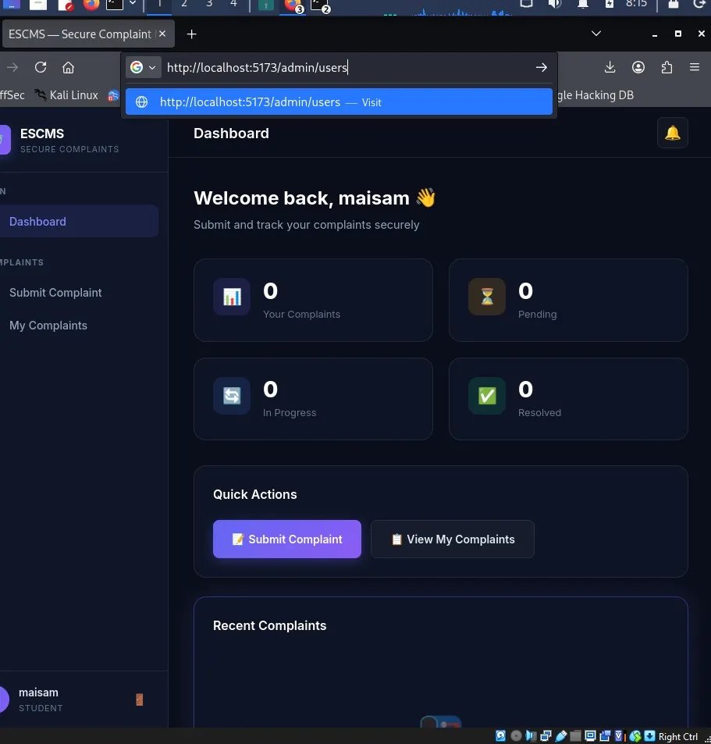
Figure 5: Student 'maisam' attempting to access /admin/users via direct URL entry in the browser address bar

4.2 URLs Tested
URL Tested | Expected | Result
http://localhost:5173/admin | 403 / Redirect | PASS – Access Blocked
http://localhost:5173/admin/users | 403 / Redirect | PASS – Access Blocked
http://localhost:5173/admin/complaints | 403 / Redirect | PASS – Access Blocked

5. Findings & Analysis
Field | Detail
Vulnerability Tested | Unauthorized Admin Access – Vertical Privilege Escalation
Attack Technique | Forced Browsing / Direct URL Access
Endpoint Targeted | http://localhost:5173/admin/users
Tester Account Role | STUDENT (low privilege)
Expected Behavior | 403 Forbidden or redirect to login page
Actual Behavior | Admin routes are protected; student access denied
Server-Side Auth? | YES – Role-based access control enforced
Vulnerability Present? | NO – Admin panel properly secured
Test Result | PASS

The application enforces role-based access control (RBAC) on the backend. Simply knowing an admin URL as a student user does not grant access to admin functionality. The server validates the user's role before serving any admin-restricted content, independent of what is displayed in the user interface.

6. Conclusion & Recommendations

6.1 Conclusion
The ESCMS application correctly implements server-side authorization for administrative routes. A standard student user attempting to access admin panels (such as /admin/users) via direct URL manipulation is appropriately denied access. This confirms that the application does not rely on security through obscurity and instead enforces proper role-based access control.

6.2 Recommendations
- Ensure ALL admin routes return HTTP 403 (Forbidden) or redirect to login — verify this across every admin endpoint.
- Implement automated API and route authorization tests in the CI/CD pipeline to prevent regressions.
- Apply the principle of least privilege across all user roles in the system.
- Use middleware-level route guards on the backend for admin paths rather than relying on frontend routing alone.
- Regularly audit and review role definitions to ensure no unintentional privilege grants occur.
- Consider implementing rate-limiting and alert mechanisms for repeated unauthorized access attempts.

Prepared by: Abdullah Ahtasham
Application: ESCMS – Secure Complaint Management System
Date: Tue May 05 2026

